***Tugas algoritma dan struktur data***

Anggota kelompok

* Rinaldi saefutra(2022240044)
* Rafly akbar yaurdi(2022240056)
* Nobel masina arben

Tugas bab 4 dan juga bab 6 seharus nya di kerjakan oleh **Nobel masina arben** tapi sampai sekarng dia belum mengerjakan tugas nya

***Bab 1***

***Bab 2***

***Bab 3***

***Bab 5***

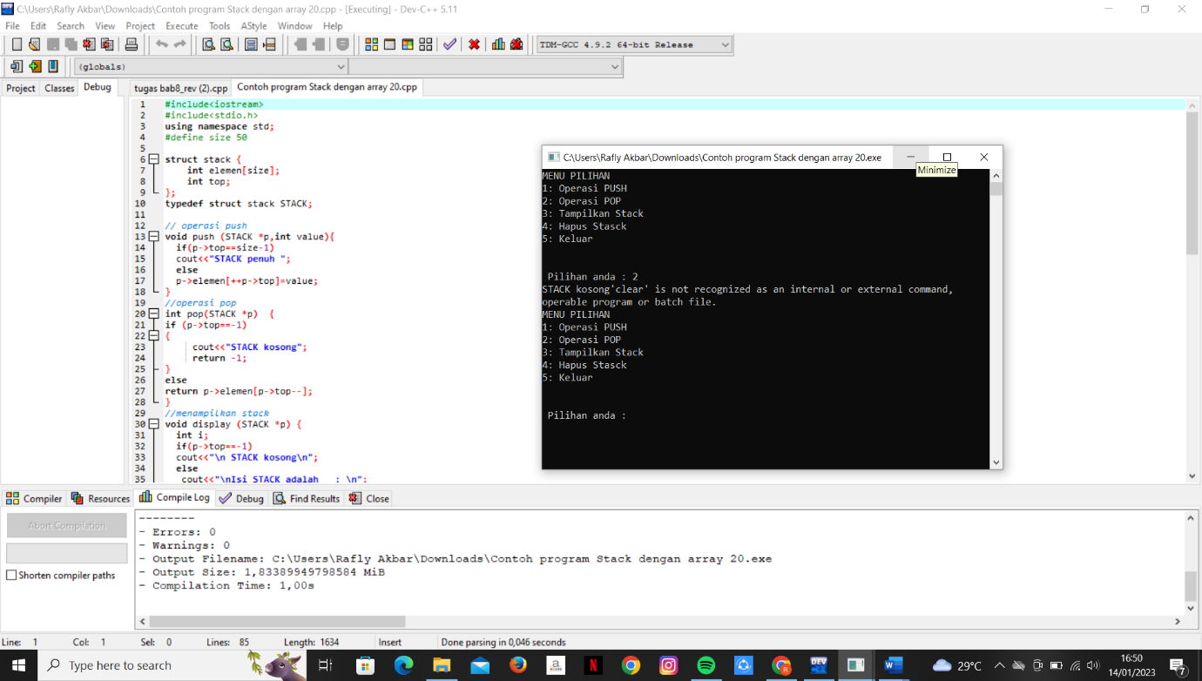

***Bab 7***

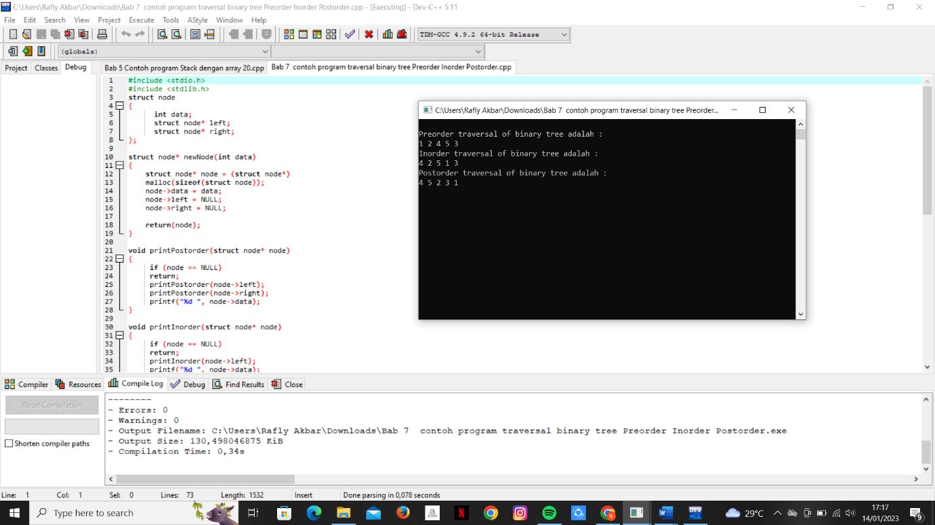

***Bab 8***

